Lab 7

Name: Saqba Yasmin
Sap Id: 63476
Program: BSCS-3
Submitted to: Mam Rehana Sanam
LAB TASKS

Class task 1
Q: Division variable with no value.

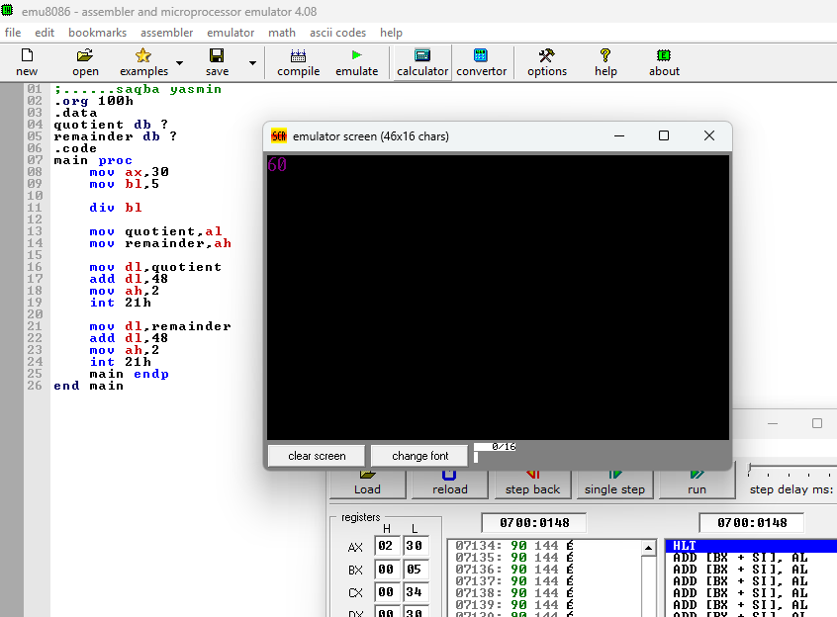

Class task 2
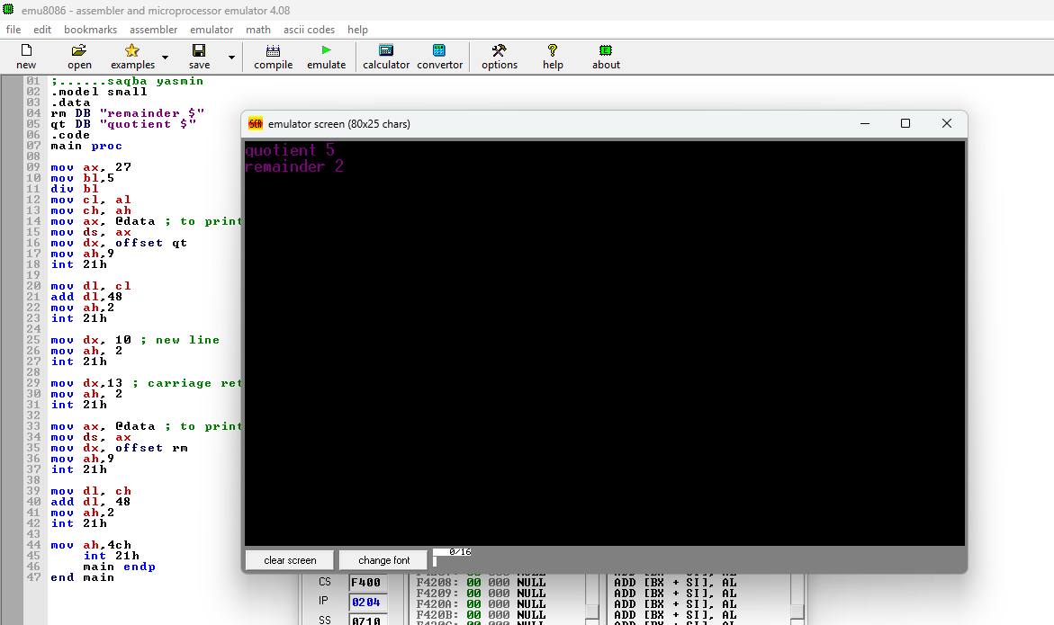

Task 1:
;saqiba yasmin
.model small
.stack 100h
.data
msg1 db
msg2 db 0Dh,0Ah,
msg3 db 0Dh,0Ah,
num1 db ?
num2 db ?
result db ?

.code
main proc
mov ax, @data
mov ds, ax

mov dx, offset msg1
mov ah, 09h
int 21h

mov ah, 01h
int 21h
sub al, 30h

mov dx, offset msg2
mov ah, 09h
int 21h

mov ah, 01h
int 21h
sub al, 30h
mov num2, al

mov al, num1
mov bl, num2
mul bl
mov result, al

mov dx, offset msg3
mov ah, 09h
int 21h

mov dl, result
add dl, 30h
mov ah, 02h
int 21h

int 21h
main endp
end main

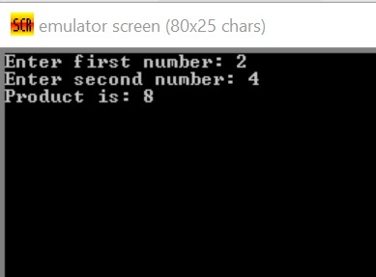

Task 2:
.model small
.stack 100h
.data
msg1 db 'Enter a number (0-9): $'
msg2 db 0Dh,0Ah, 'Square of the number is: $'
num db ?
result db ?
.code
main proc
mov ax, @data
mov ds, ax

mov dx, offset msg1
mov ah, 09h
int 21h

mov ah, 01h
int 21h
sub al, 30h
mov num, al

mov al, num
mov bl, num
mul bl ; AL * BL = AX
mov result, al

mov dx, offset msg2
mov ah, 09h
int 21h

mov dl, result
add dl, 30h
mov ah, 02h
int 21h
mov ah, 4Ch
int 21h
main endp
end main

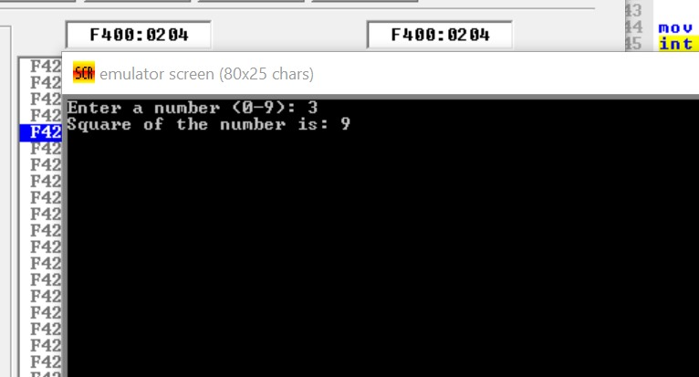
Task 3:
.model small
.stack 100h
.data
msg1 db 'Enter a number: $'
msg2 db 0Dh,0Ah, 'Cube of the number is: $'
num db ?
result db ?
.code
main proc
mov ax, @data
mov ds, ax

mov dx, offset msg1
mov ah, 09h
int 21h

mov ah, 01h
int 21h
sub al, 30h
mov num, al

mov al, num
mov bl, num
mul bl
mov bl, al
mov al, num
mul bl
mov result, al

mov dx, offset msg2
mov ah, 09h
int 21h

mov dl, result
add dl, 30h
mov ah, 02h
int 21h

mov ah, 4Ch
int 21h
main endp
end main
